**Programming Assignment 3 Report**

**(SERP Simulator 3.0)**

*Yang (Liam) Li*

*CS146-S7*

Previous version:

1.0: Using Heap and Priority Queue

2.0: Using Quick Sort, Binary Search Tree and Bucket Sort

**Current**

3.0: Using Red Black Tree

Contents

1) Installation (p3 – p4)

2) Software Design (p4)

3) Implementation (p5 – p10)

4) Functions/Classes (p11 – p18)

5) Testing (p19– p23)

6) Problems (p24)

7) Learnings (p24)

**1) Installation**

* Unzip the zip folder, there are three part, an SRC folder that contains all of the .java files, a Program Report which is this Microsoft Word Document you are reading it now and a runnable .jar file called “Google Search3”.
* Open the jar file and start testing! Warning (MacOS only): if you have the alert the “can’t be opened because it is from an unidentified developer”, go to the System Preference -> Security and Privacy -> General -> Allowed apps downloaded from and let this app open!
* You can modify the code, or compile/run by yourself, you can simply create a **Java FX projects** in any IDE (Eclipse and IntelliJ are tested and highly recommended) and copy the files from SRC folder to your project.

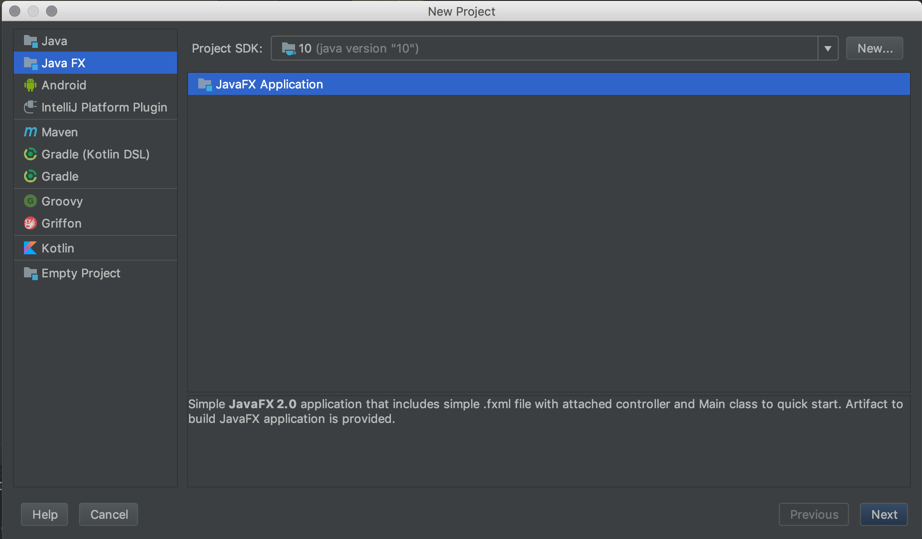

* This program is using JSOUP library to web crawl the results from google search, you need to download JSOUP whether in Marven or I have downloaded the library for you, simply **click the file -> Project Structure ->Project Settings ->Libraries ->click the plus symbol and select the JSOUP Zip file in the same folder as the SRC files(Only if the JSOUP library is not imported yet) -> click OK -> All the needed external things are installed.**

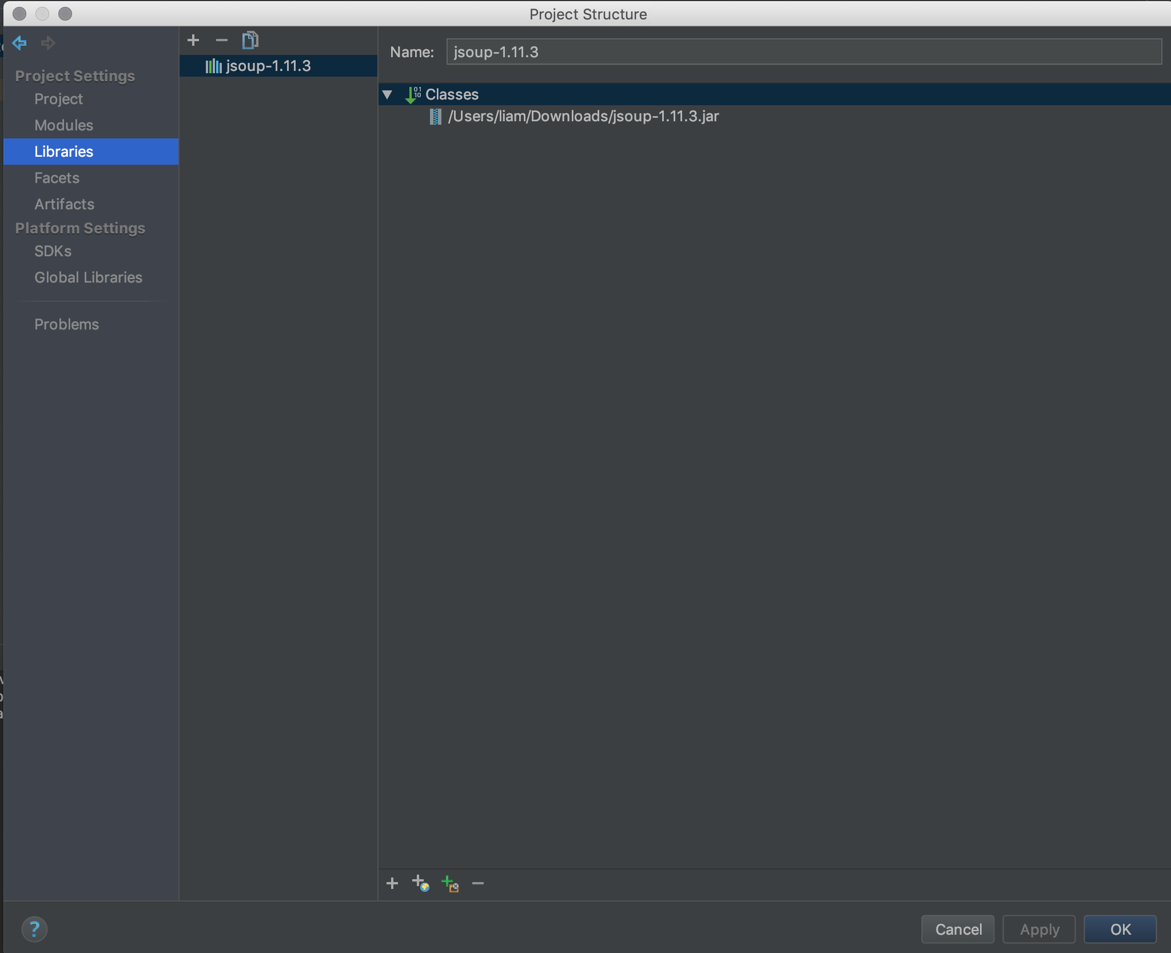

**2) Software Design**

* Using JavaFX to create the UI part of this program
* Using JSOUP library to web crawl the searches from google search
* Create a search Class called Node.java that store the variables including title, URL, position, 4 factors, total scores, PageRank, index, and left, right, parent nodes of itself and able to set them and get them.
* Create another variable called color either have “Black” or “Red”, in order to build the Red Black Tree.
* Create a Red Black Tree file that called BinarySearchTree.java that build up the red black tree by inserting results one by one to the tree. Having Insert, Delete, search features.
* By using the JavaFX, create three main scenes, that can show the 30 results, user can search the result by PageRank, insert result by URL and 4 scores, delete result by URL or total score.
* Users are able to sort the results by the total scores.

Web Crawler Library: JSOUP

GUI: Java FX Application

Data Structure: Red Black Tree

IDE: IntelliJ IDEA

System Environment: MacOS, Java 8

**3) Implementation**

**1. Main scene (Scene 1)**

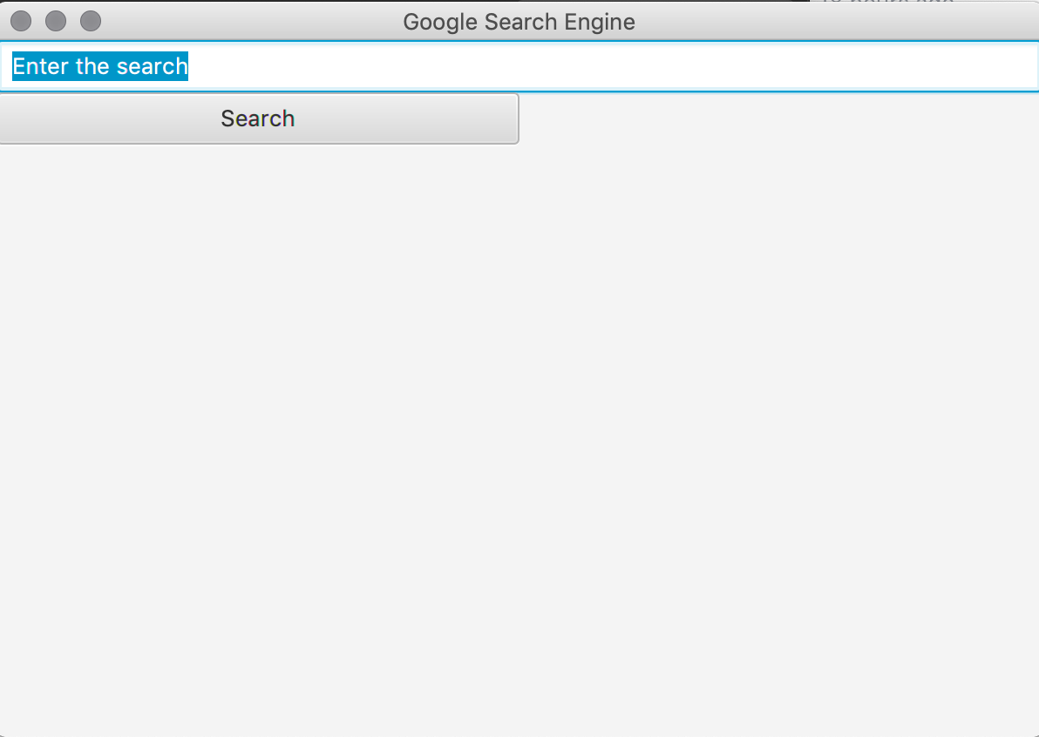

Text Field: Enter the keyword that you want to search

Search Button:

1) Have the setOnAction event, when it clicked, getting the Keyword (String) from the Text Field Above, and calling the web crawl function by using JSOUP library, getting 30 results from Google Search.

2) Inserting the Google Search into to the Red Black Tree

**2. Result Scene – Sorted by PageRank (Scene 2)**

When the Search Button clicked, it crawls the google result and insert into Red Black Tree, build up the Tree with the Color and Total Score.

1) In order walk the tree and store nodes into an Array List

2) Display order: Total Scores from Hi to Lo, PageRank from smallest(primary) to largest

3) Each result contain: Color, Index, URL, PageRank, Total Score and 4 Factor Scores

Also come with the 4 Features

1) PageRank Search: 1 Text Field and 1 Submit Button (Scene 3)

2) Insert: Go to the Insert Section Button (Scene 4)

3) Delete: Go to the Delete Section Button (Scene 5)

4) Sort based on Total Score: Sorted the Total Score from Lo to Hi Button (Scene 6)

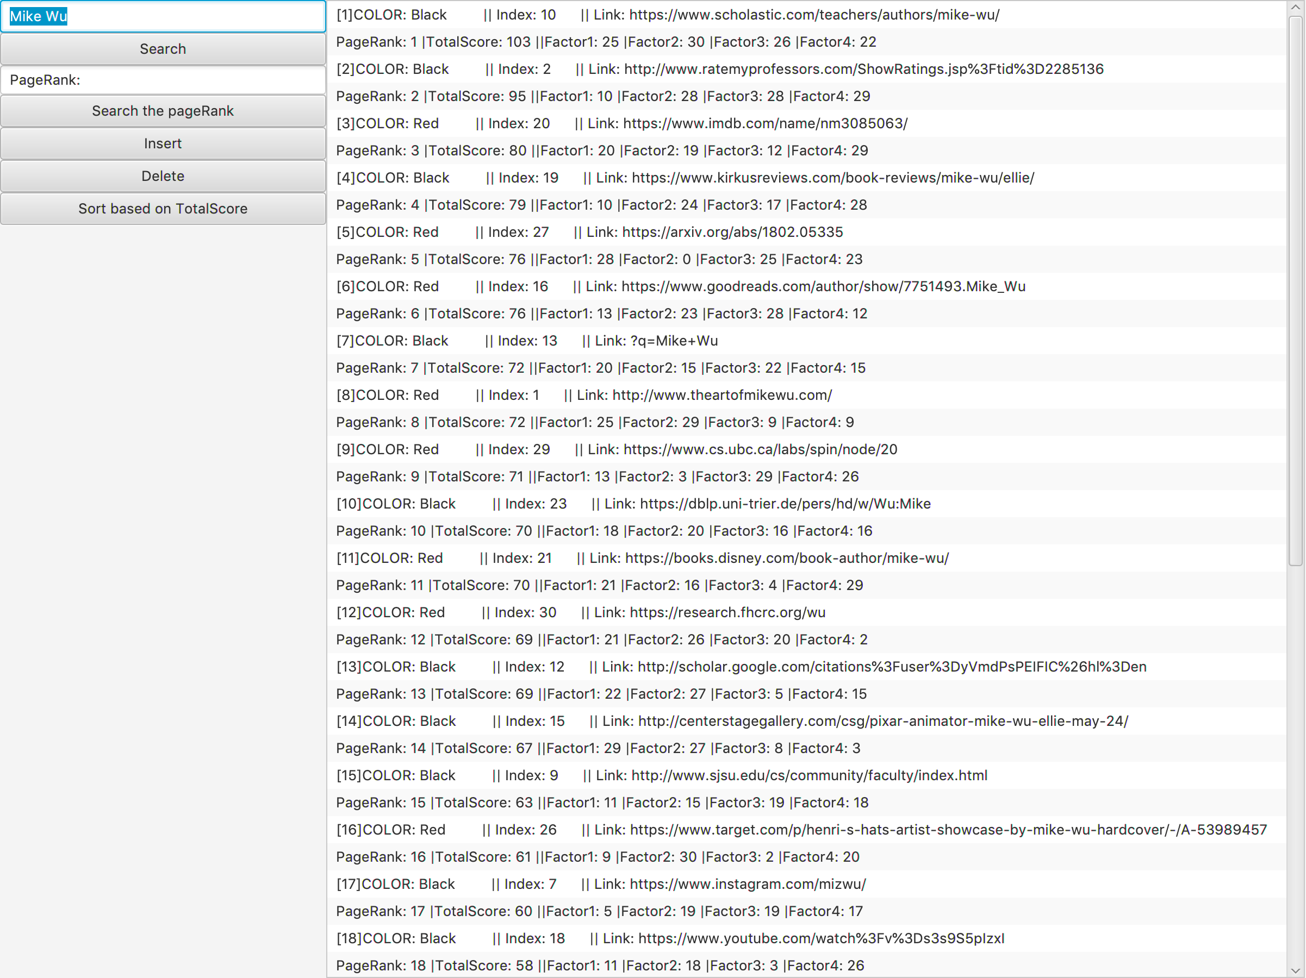

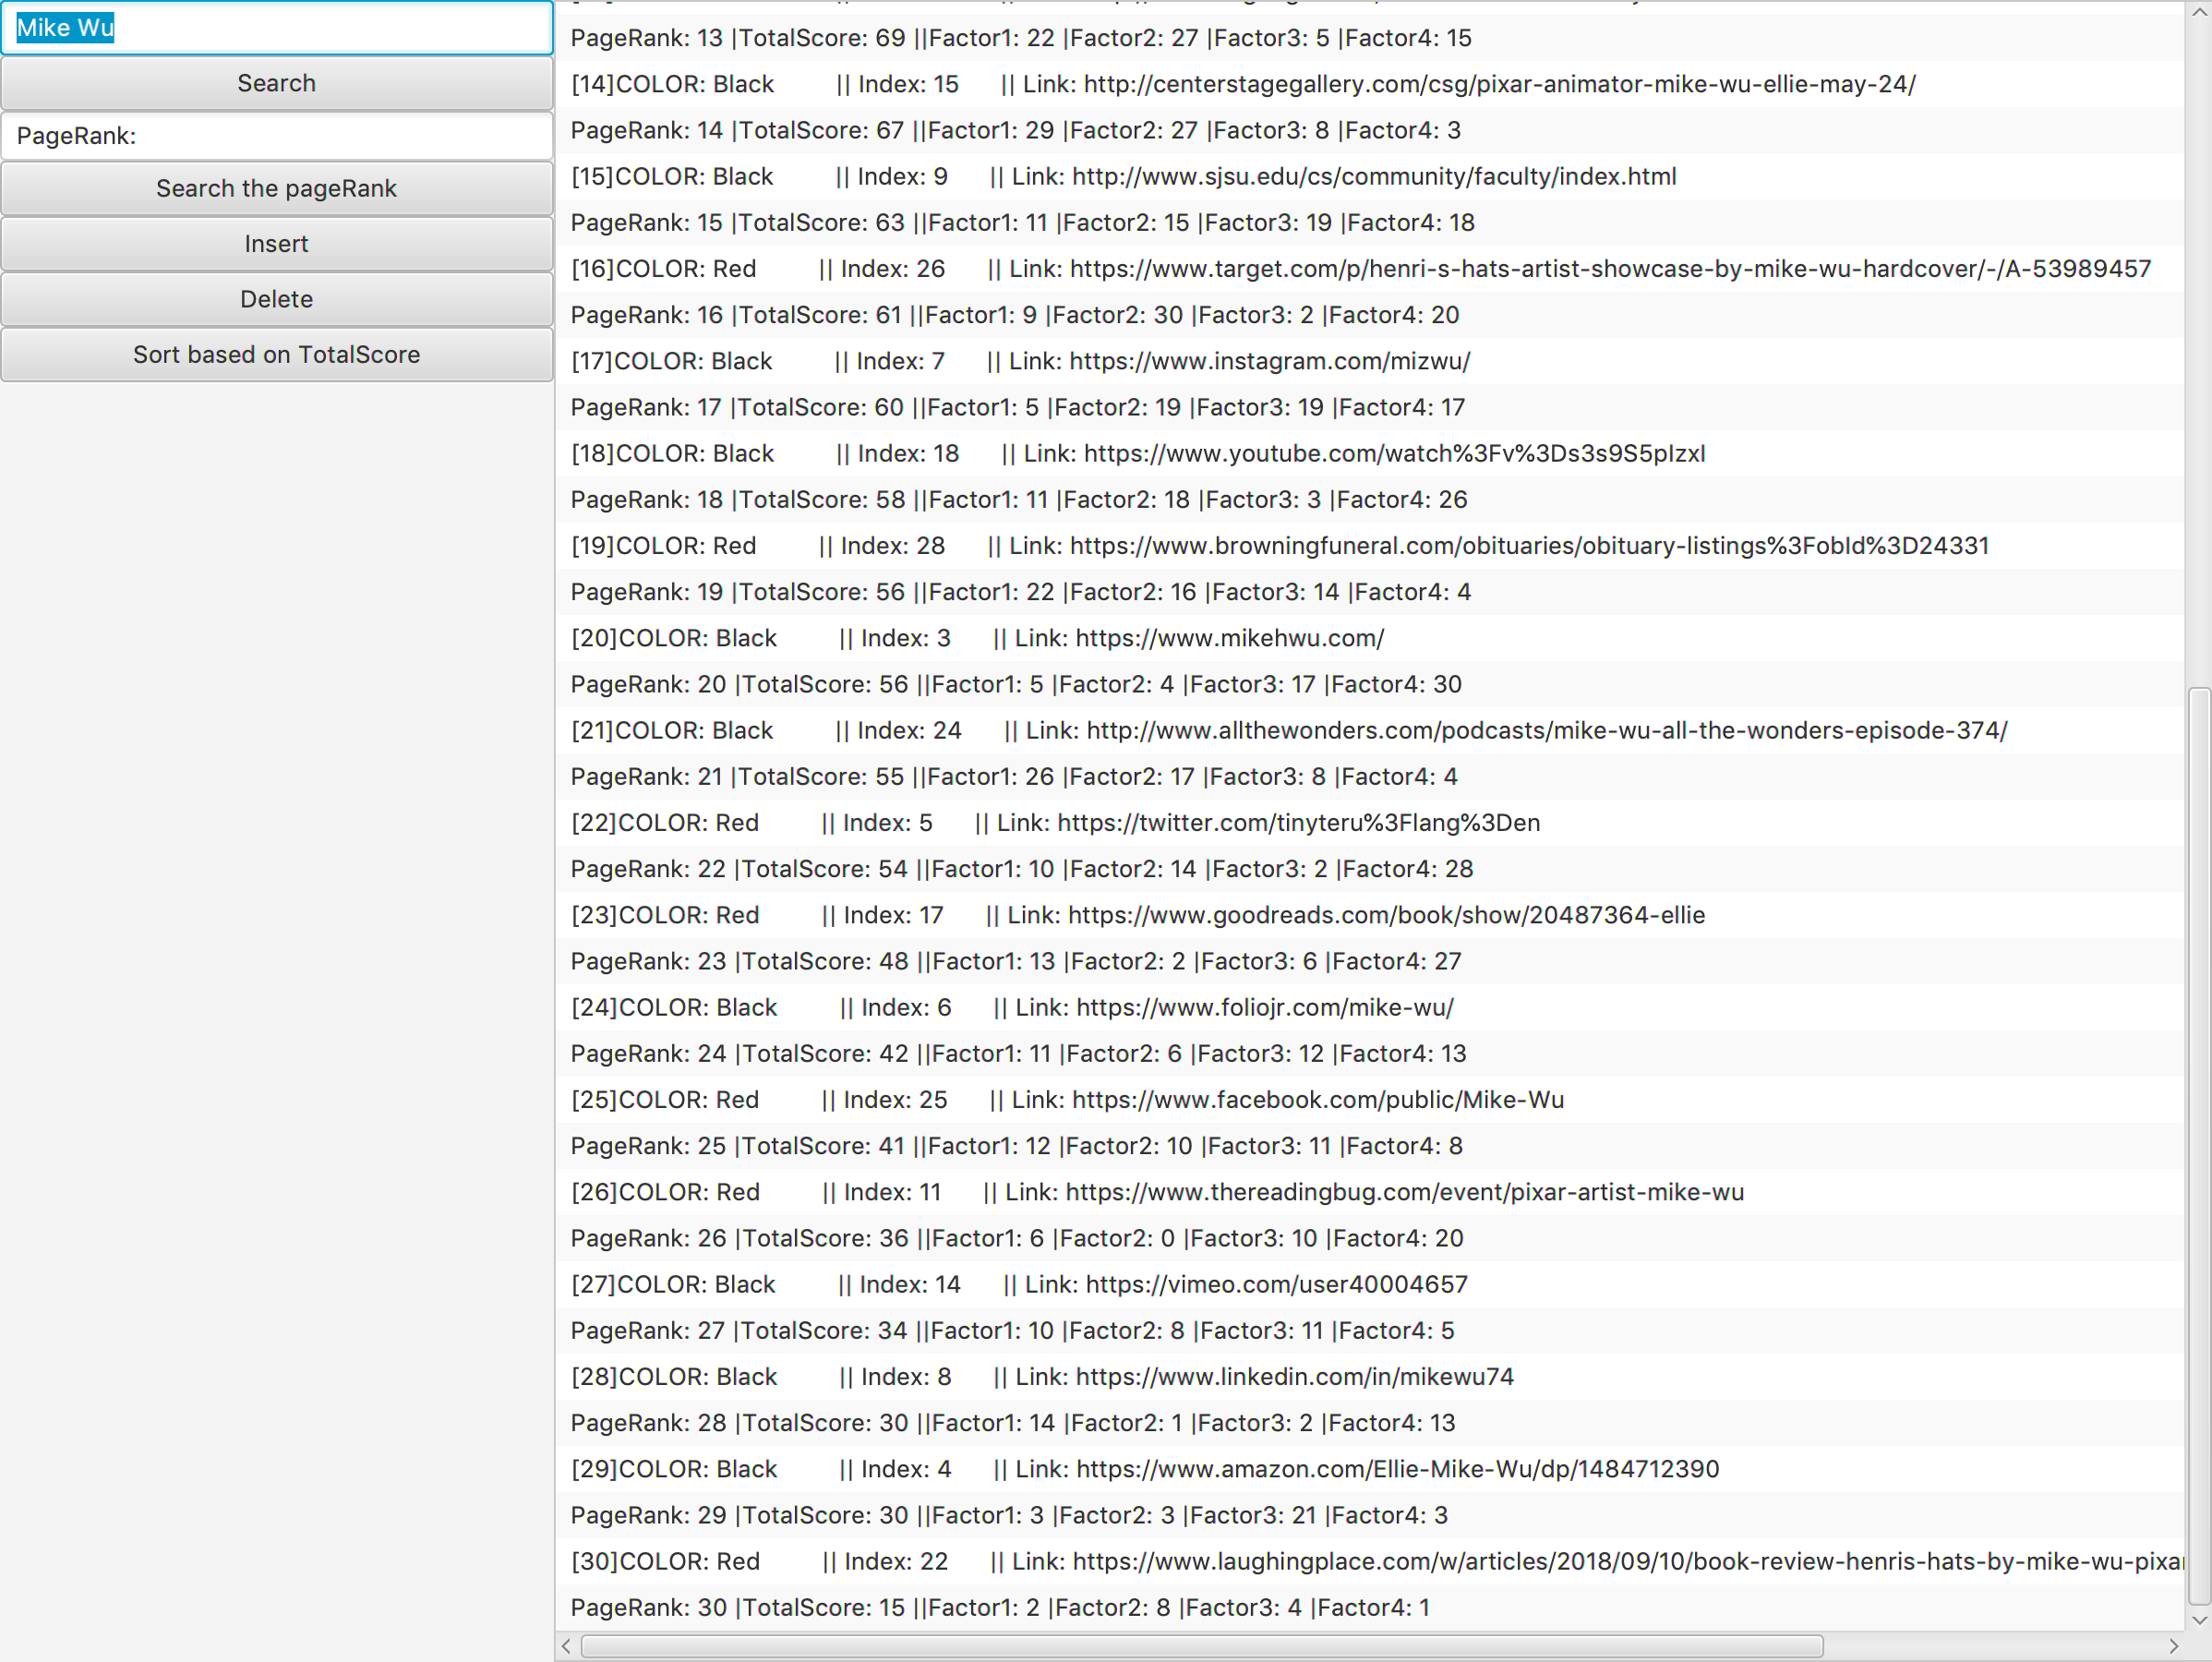

**3. PageRank Search Scene (Scene 3)**

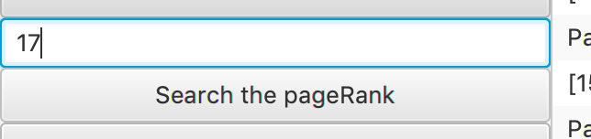

The first feature is that allow user to search the result by the Page Rank. The Text Field allow user to put the Page Rank number in it. For Example, Let’s choose “17”.

And let’s find the result from right-side view as below.



When clicked the “Search the pageRank” button, the right-side view shows up the result with the pageRank of 17. It contains one more information – Website Title, that way users can gain more information by the pageRank that they enter.

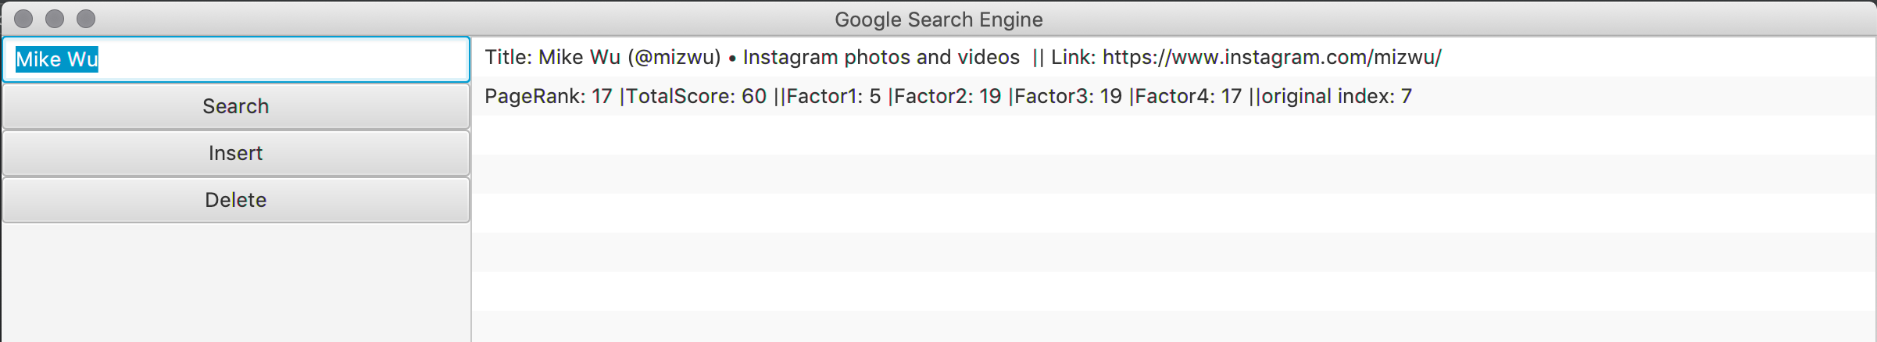

**4. Insert Scene (Scene 4)**

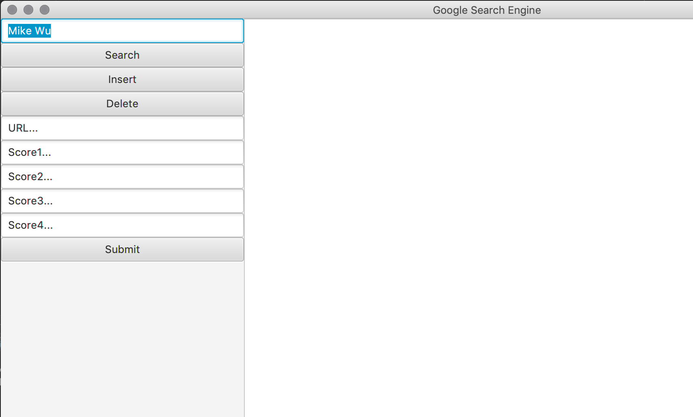

After the insert button clicked, the GUI would give user 5 Text Fields and one Submit button to insert the web result that they want. For example, I chose to put [www.iloveMikeWu.com](http://www.iloveMikeWu.com) as the input URL, and input 25, 25, 20, 20 as the 4 factors of the Total Scores.

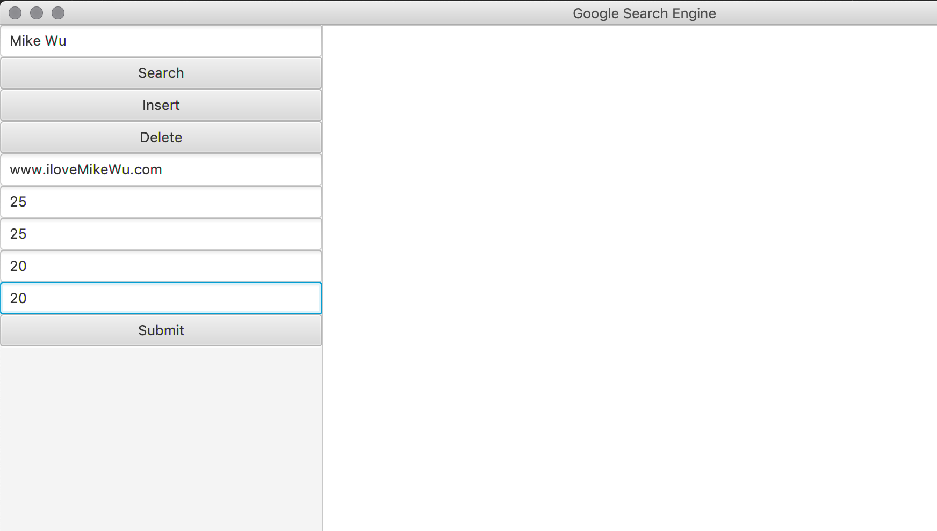

Once I click the submit button, it would display the result on the right side with the new object in the right order.

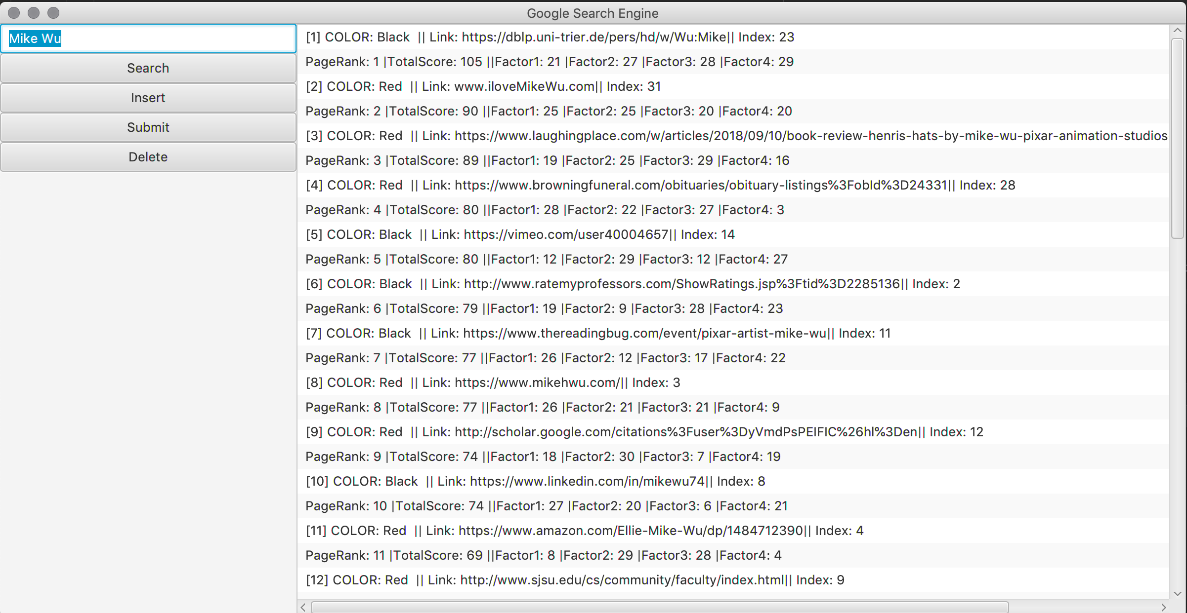

As you can see, it goes to pageRank 2, because the total score is the second highest, with the index of 31.



**5. Delete Scene (Scene 5)**

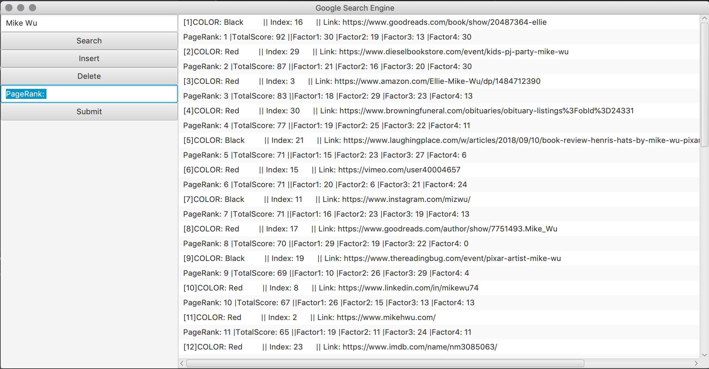

After the Delete button is clicked, it would display the Text Field that allow user to delete the Result by the pageRank. For Example, let’s choose pageRank 6.

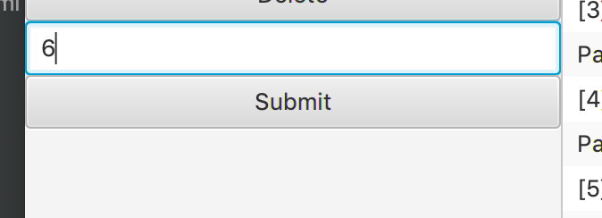



We can find the corresponding result from the right-side view.

Color: Red, Index 15, PageRank: 6 with Total Score 71

And we are ready to click the Submit button to expect the result above is no longer exist.

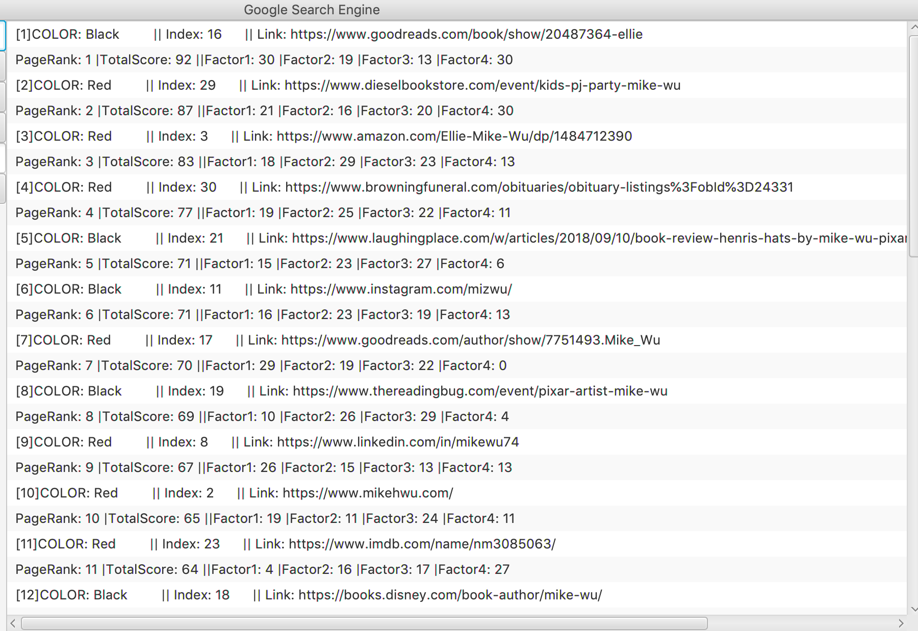

As you can see, the result with index of 15 is no longer exits. The original pageRank 6 is deleted, the new pageRank 6 was the originally pageRank 7 with index of 11.

**6. Sorted based on Total Score Scene (Scene 6)**

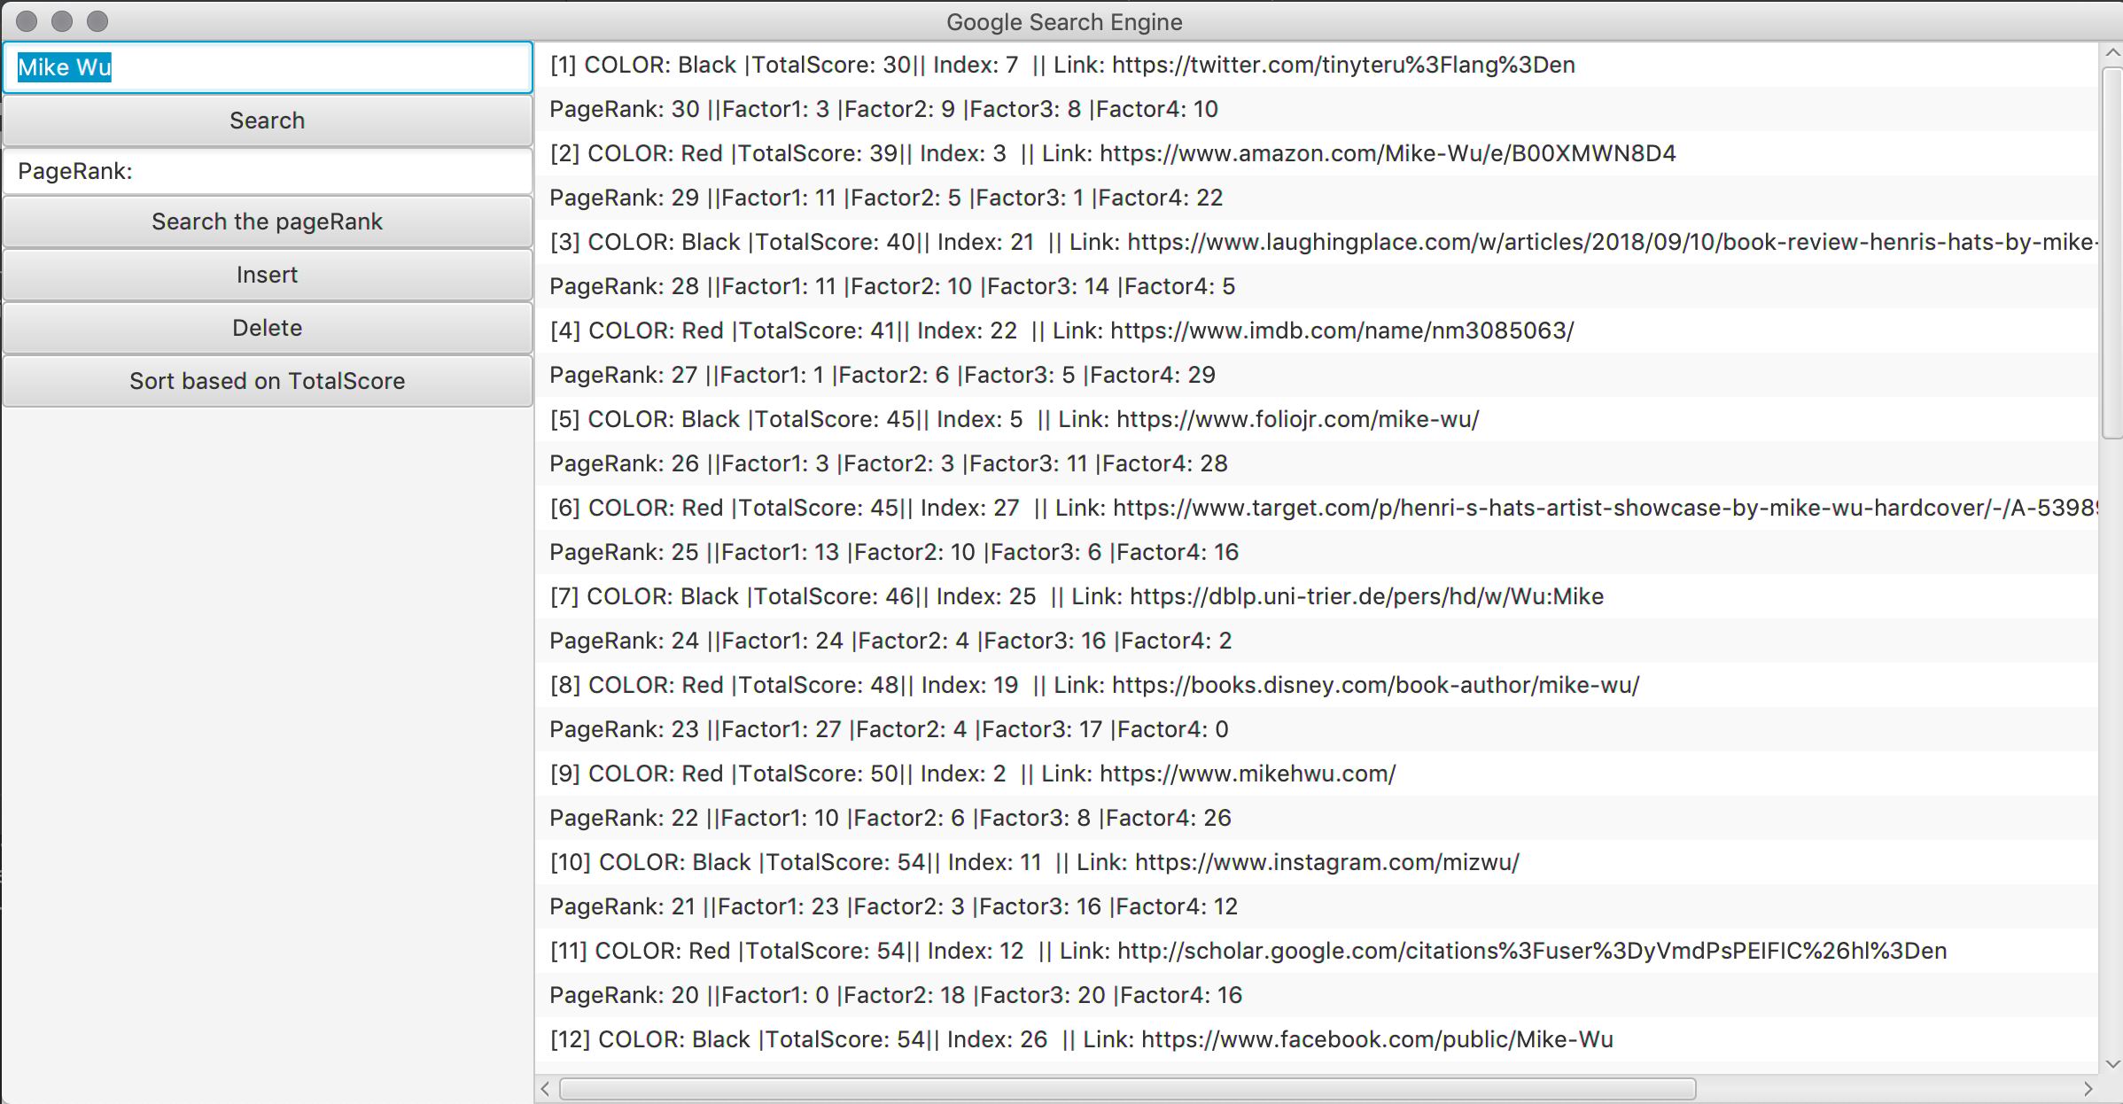

When the “Sort based on TotalScore” button clicked, it would display the 30 results in order from lowest Total Score to highest Total Score, as the PageRank from Highest to Lowest. It gives users more option to see the data.

**4) Functions/Classes**

**Main.java**

* Web crawler: Using JSOUP to connect the URL and setting the userAgent, from the div of the google search website, we know the search result is contained in the div of h3, so we can just only get what we want from the div of h3.
* UI components: List View, Button, Test Field



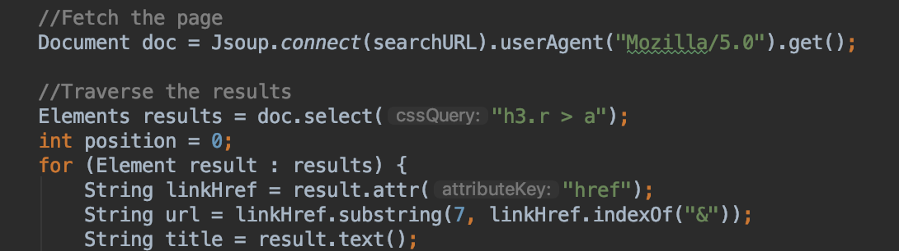

In Order RB Tree Walk, be able to travel the tree in order and return it as an Array List by taking the root, the Nil and the old Array List

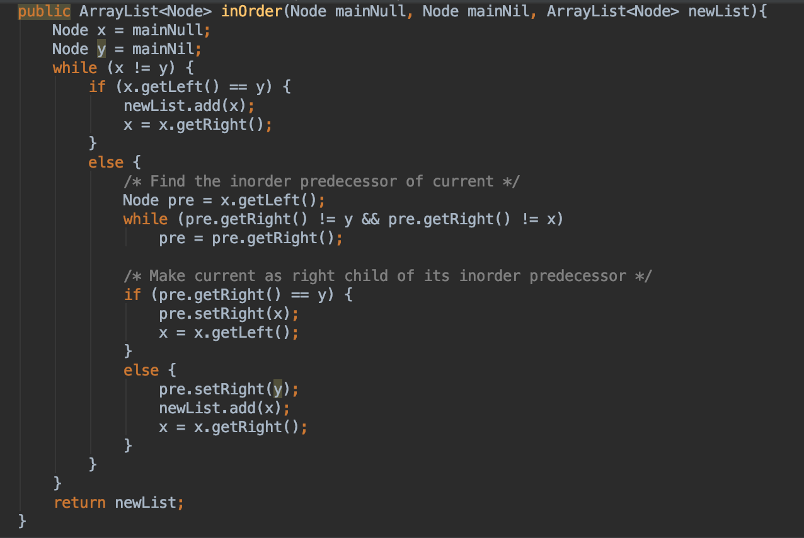

Have 6 button click function inside with the Search click function

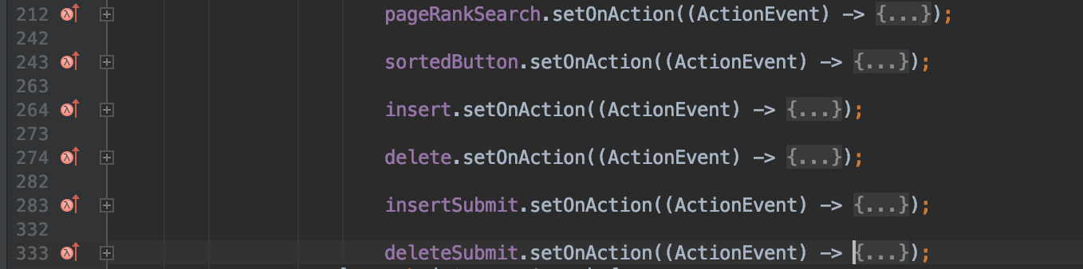

Corresponding to different features.

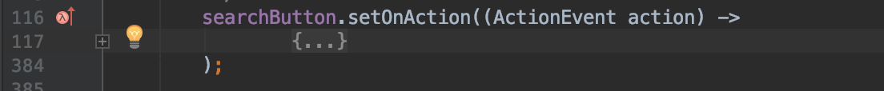

**Node.java**

Having all the information of one result. Total score equal to the sum of 4 scores, pageRank assign lowest to the highest TotalScore. Position represent the original index when the result gets inserted. Having additional variable called color keep track and used in Red Black Tree

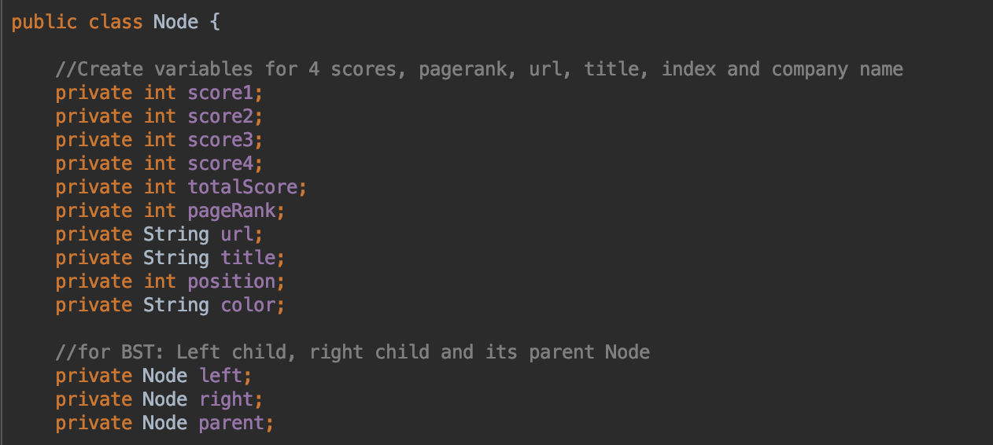

**RBTree.java**

Root Node and Nil for RB Tree Data Structure

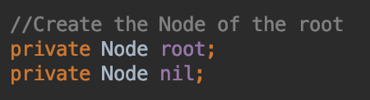

Constructor:

* Initiate the Nil node
* Set the Nil always equal to Black color and the root as Nil

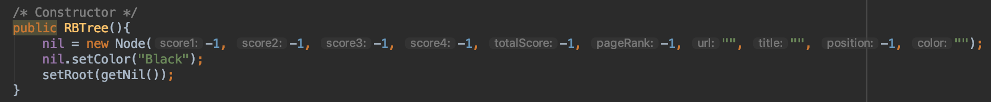

RBTree Search Method

* Return the node if the key match recursively.
* Keep going left if the key less than
* Keep going right if the key greater than

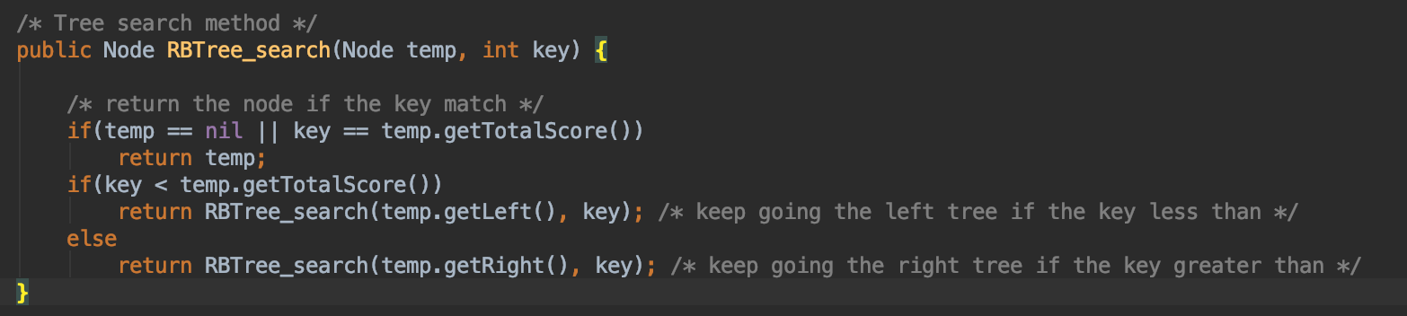

Left rotate and Right Rotate Method (Same functionality as BST )

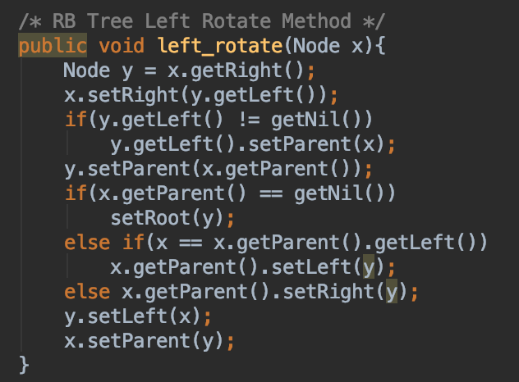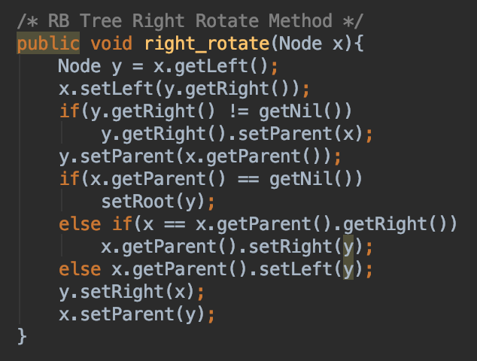

RB Tree Insert Method

* Set the first inserted Node as root
* Having the inserted Node both children are Nil, and inserted Node as Red Color
* Others would be same as the BST insertion
* Goes to the fixup Method whenever inserting a new Node

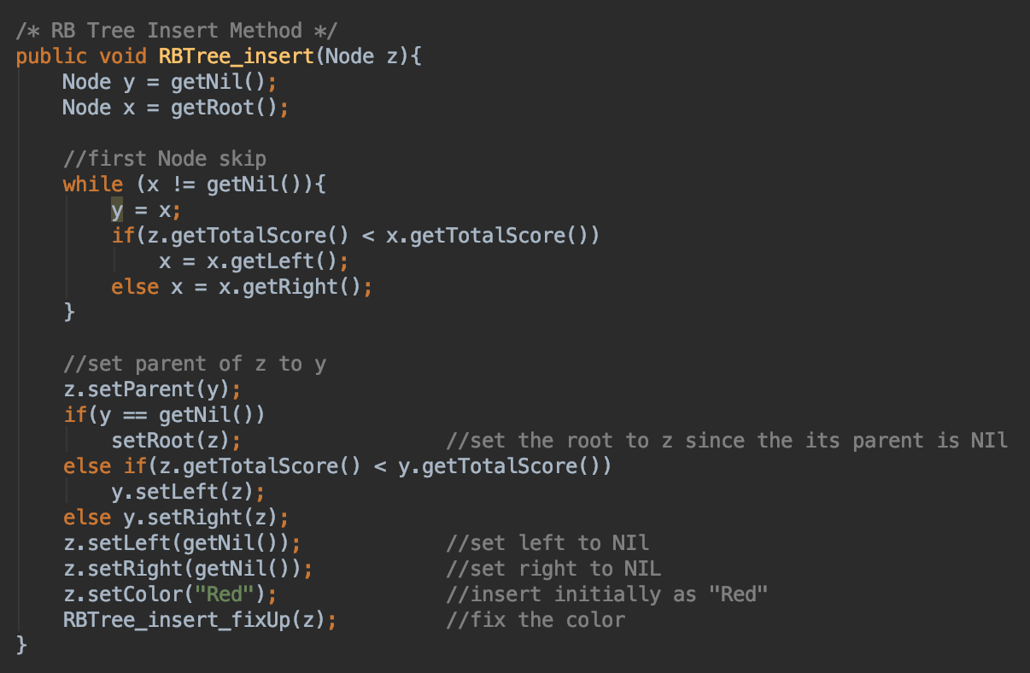

RB Tree Insertion Fix Up Method

* Case 1: if the inserted Node’s uncle is red
* Case 2a: if the inserted Node’s uncle is black (inserted Node is the left child and its parent is the left child)
* Case 2b: if the inserted Node’s uncle is black (inserted Node is the right child and its parent is the left child)
* Case 3a: if the inserted Node’s uncle is black (inserted Node is the right child and its parent is the right child)
* Case 3b: if the inserted Node’s uncle is black (inserted Node is the left child and its parent is the right child)

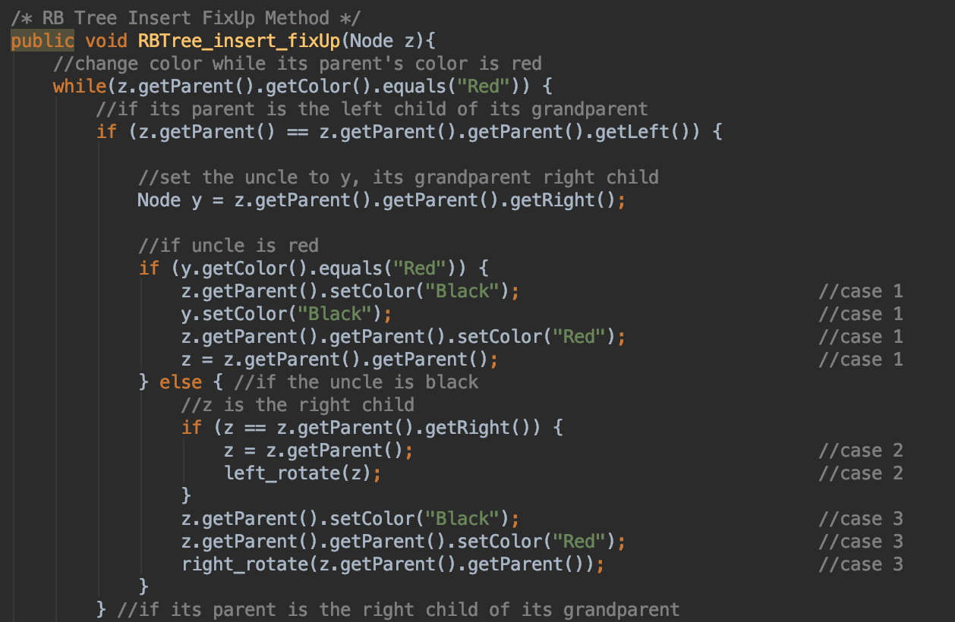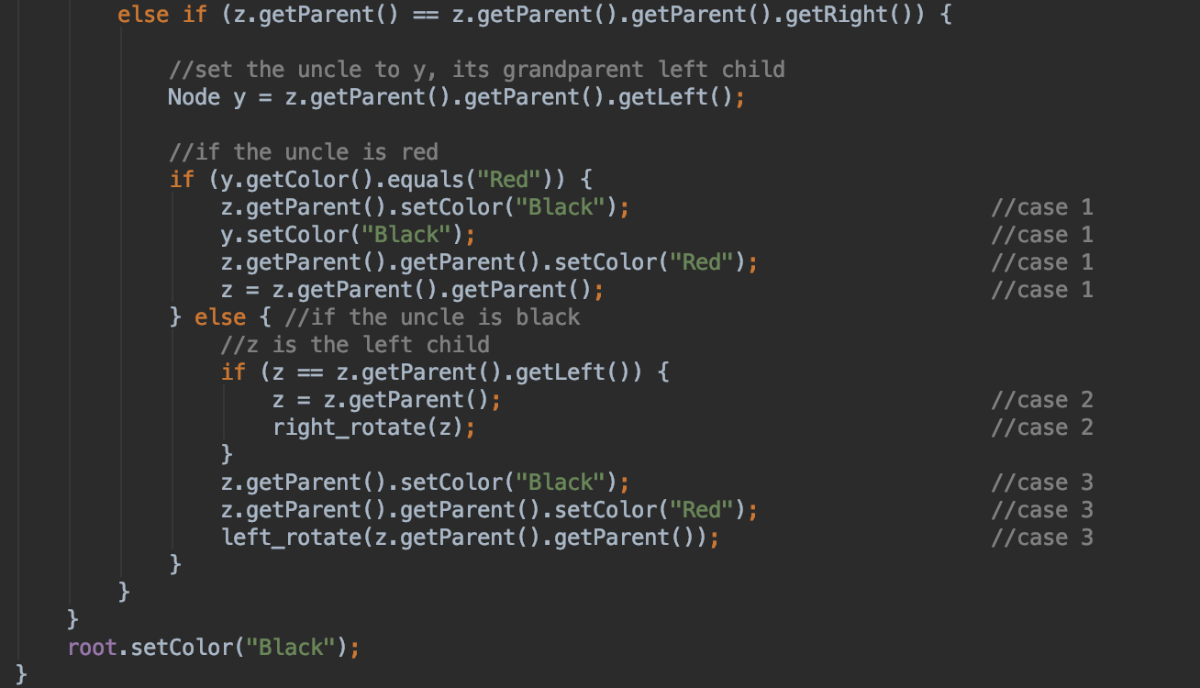

RB Tree Transplant Method

* Case 1: if the u’s parent equal to Nil, then set the root as v.
* Case 2: if the u is the left child of its parent, then replace u as v.
* Case 3: if the u is the right child of its parent, then replace u as v.

Redirect u’s parent as v’ s parent

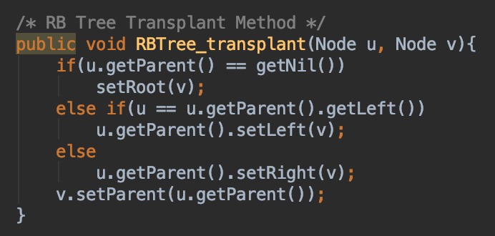

RB Tree Delete Method

* Case 1: if the deleted Node have the right child.
* Case 2: if the deleted Node have the left child.
* Case 3: if the deleted Node have both children.
* Store the original color of deleted Node
* If the original color is black, then it needs to go to the fixup method in order to keep the properties of the RB tree.

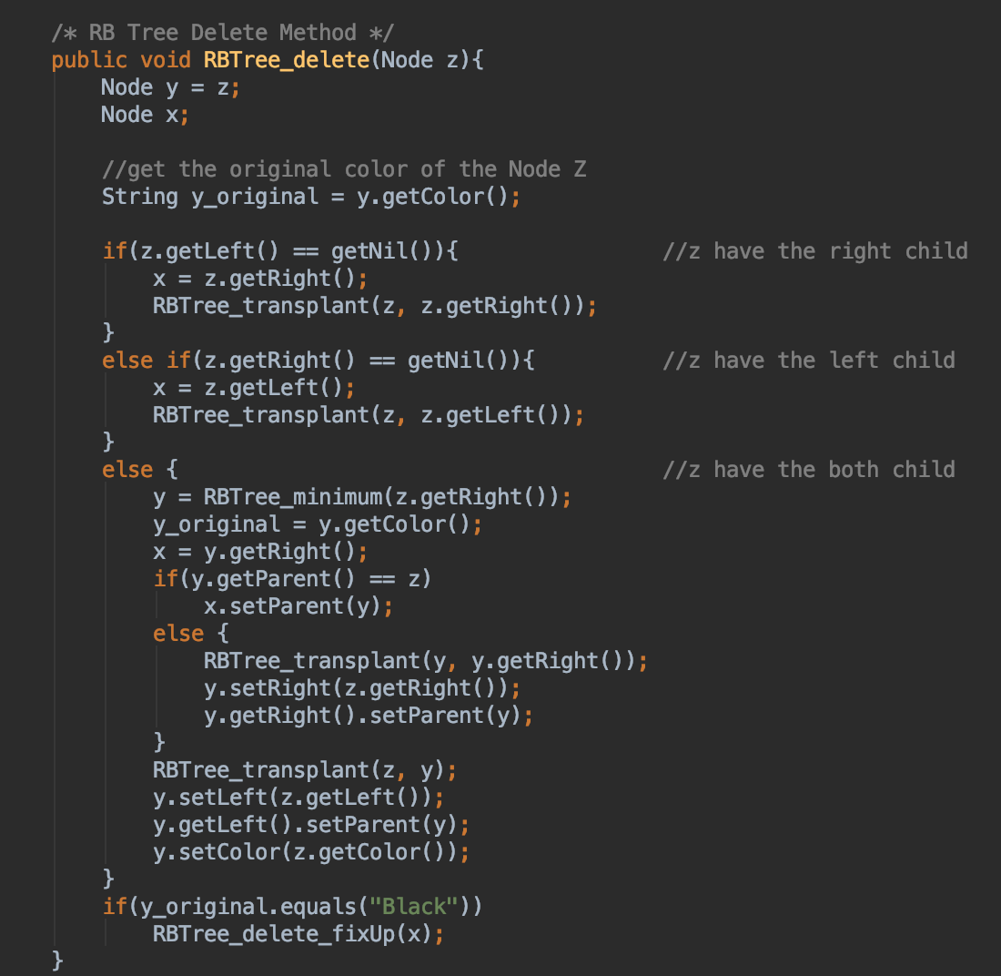

RB Tree Delete Fixup method

* Have four cases for left child and four cases for right child.
* I would be discuss this more thoroughly in testing section (p21)

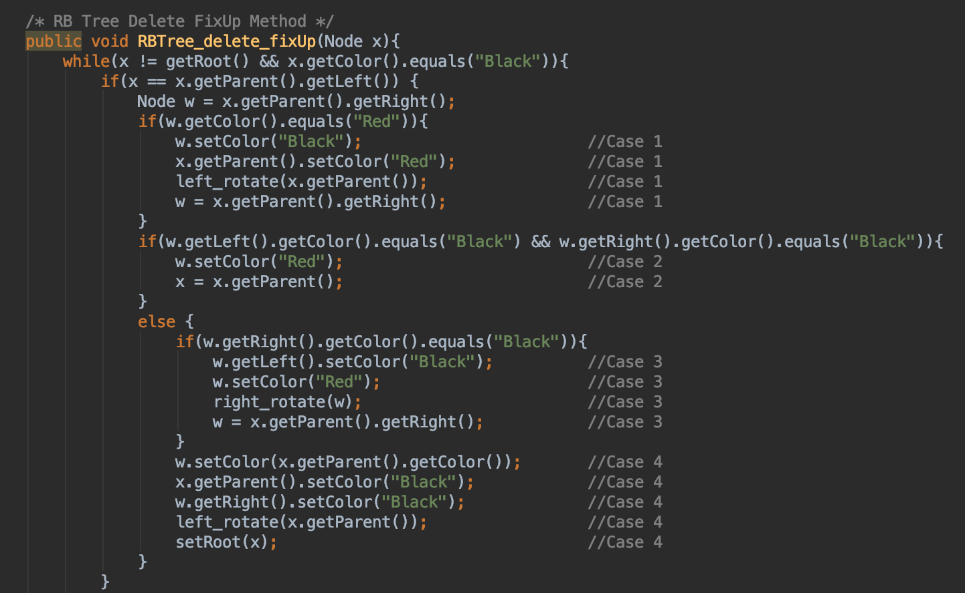

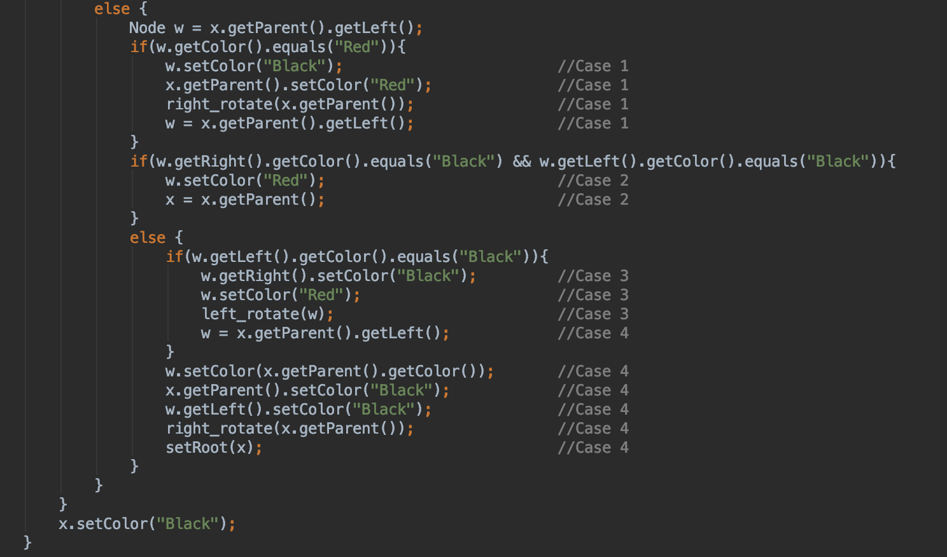

RB Tree Minimum Method

* Getting the smallest Node at the very end of the left tree

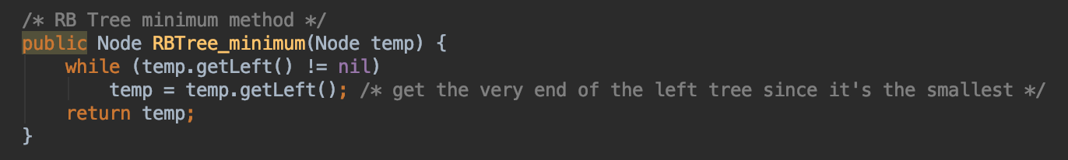

Setter and Getter of the Root Node and Nil.

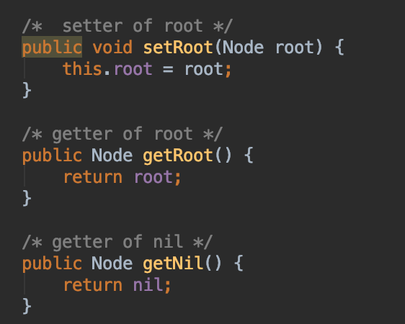

**5) Testing (Insertion and Deletion)**

The best way of testing RB Tree is drawing the tree by hand and compare to the result that comes with the program. But for better practice and easier to observe, I use 10 results from the web crawler instead of using 30 results.



While getting the 10 results, break the loop of getting results from web crawler.

**a) Insertion and Insertion FixUp Testing**

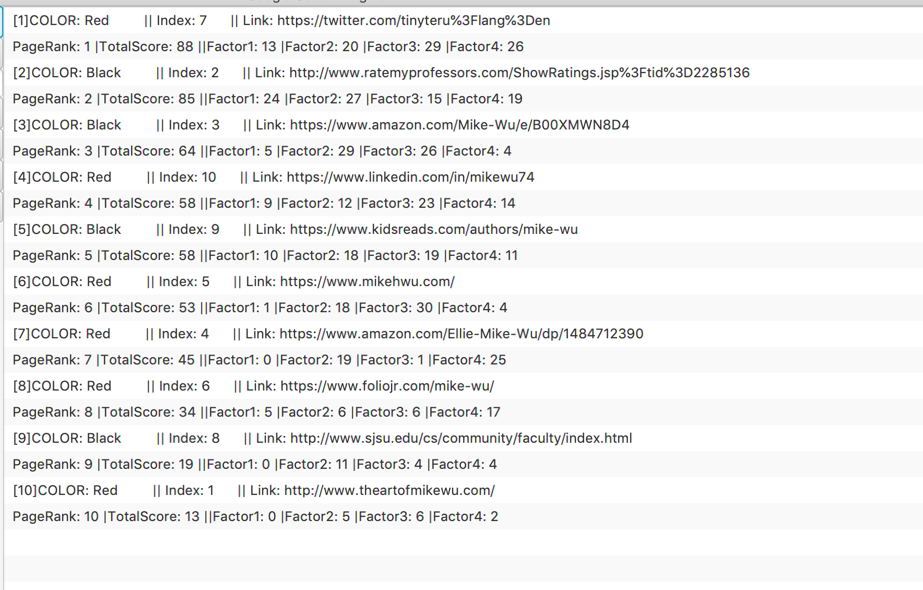

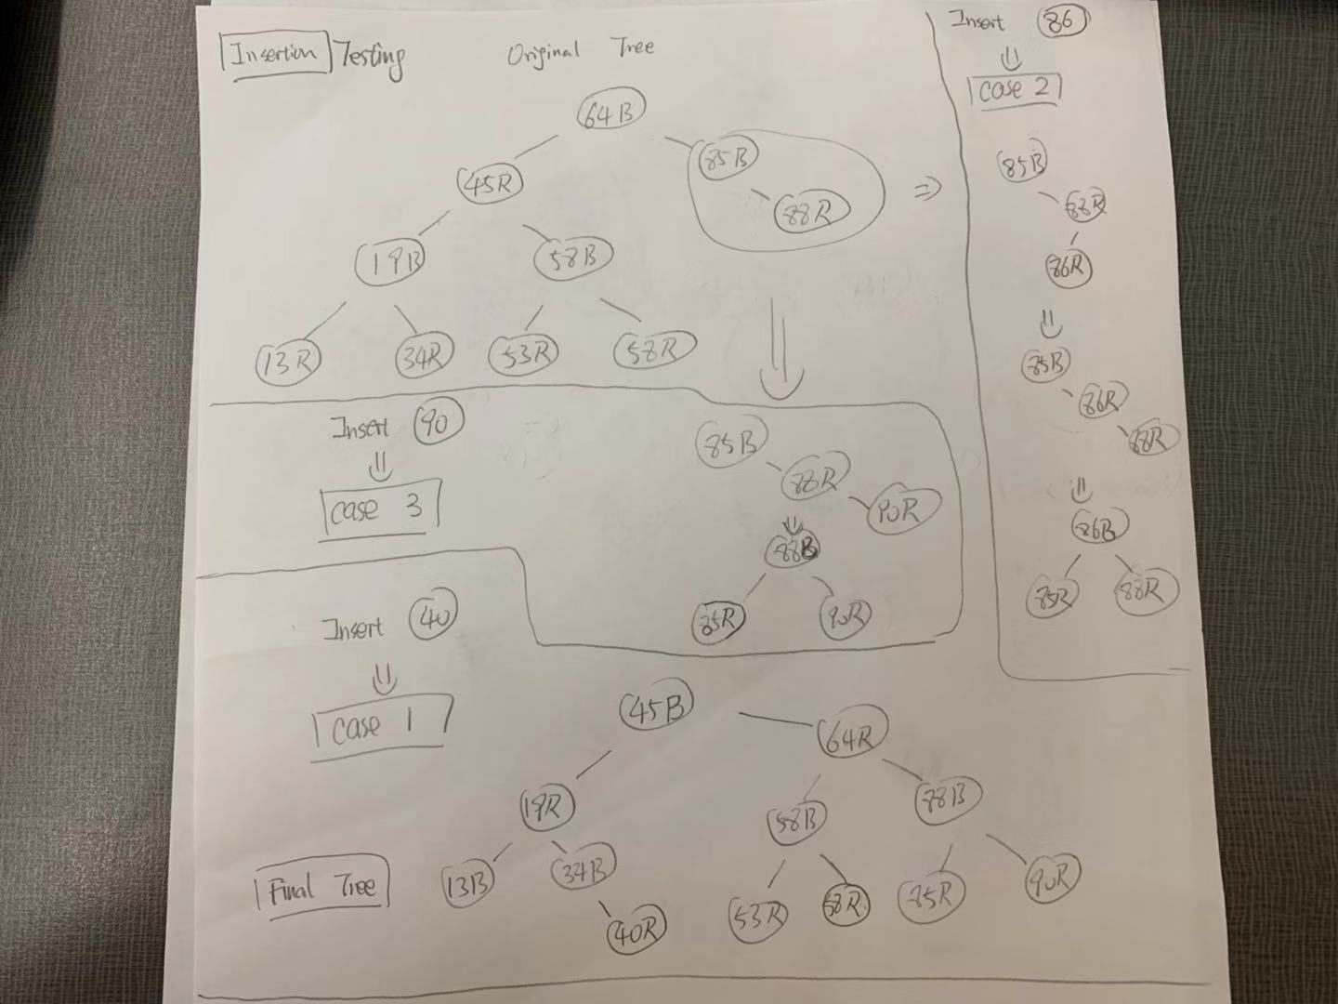

After inserting 10 results, the tree and color property is exactly the same as above

Now let’s test the 3 cases from Fix Up method

Case 1: Insert 40

Case 2: Insert 86

Case 3: Insert 90



As you can see,

Case 2: When the inserted Node (86) is the left child of its parent and they are both red while its grandparent is black, it does the right rotate first and then left rotate, change color for itself and its grandparent to make the RB Tree balance and fix the properties.

Case 3: When the inserted Node (90) is the right child of its parent and they are both red while its grandparent is black, it does the left rotate once and change the color for its parent and grandparent, not itself, to make the RB Tree balance and fix the properties.

Case 1: When the inserted Node (40) is the right child of its parent and its parent is not the only child, it needed to left rotate its grandparent to change the entire tree to change fix the properties and make the RB Tree balance.

When the cases of insertion all get tested, moving on to the Deletion Testing.

**b) Deletion and Deletion FixUp Testing**

Let’s use another set of Data of deletion for better observation, also using only 10 results. If cases not found, insert more Nodes until the 4 cases all found.

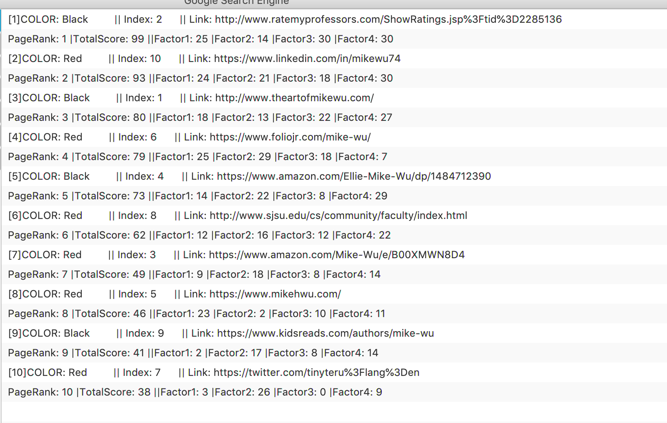

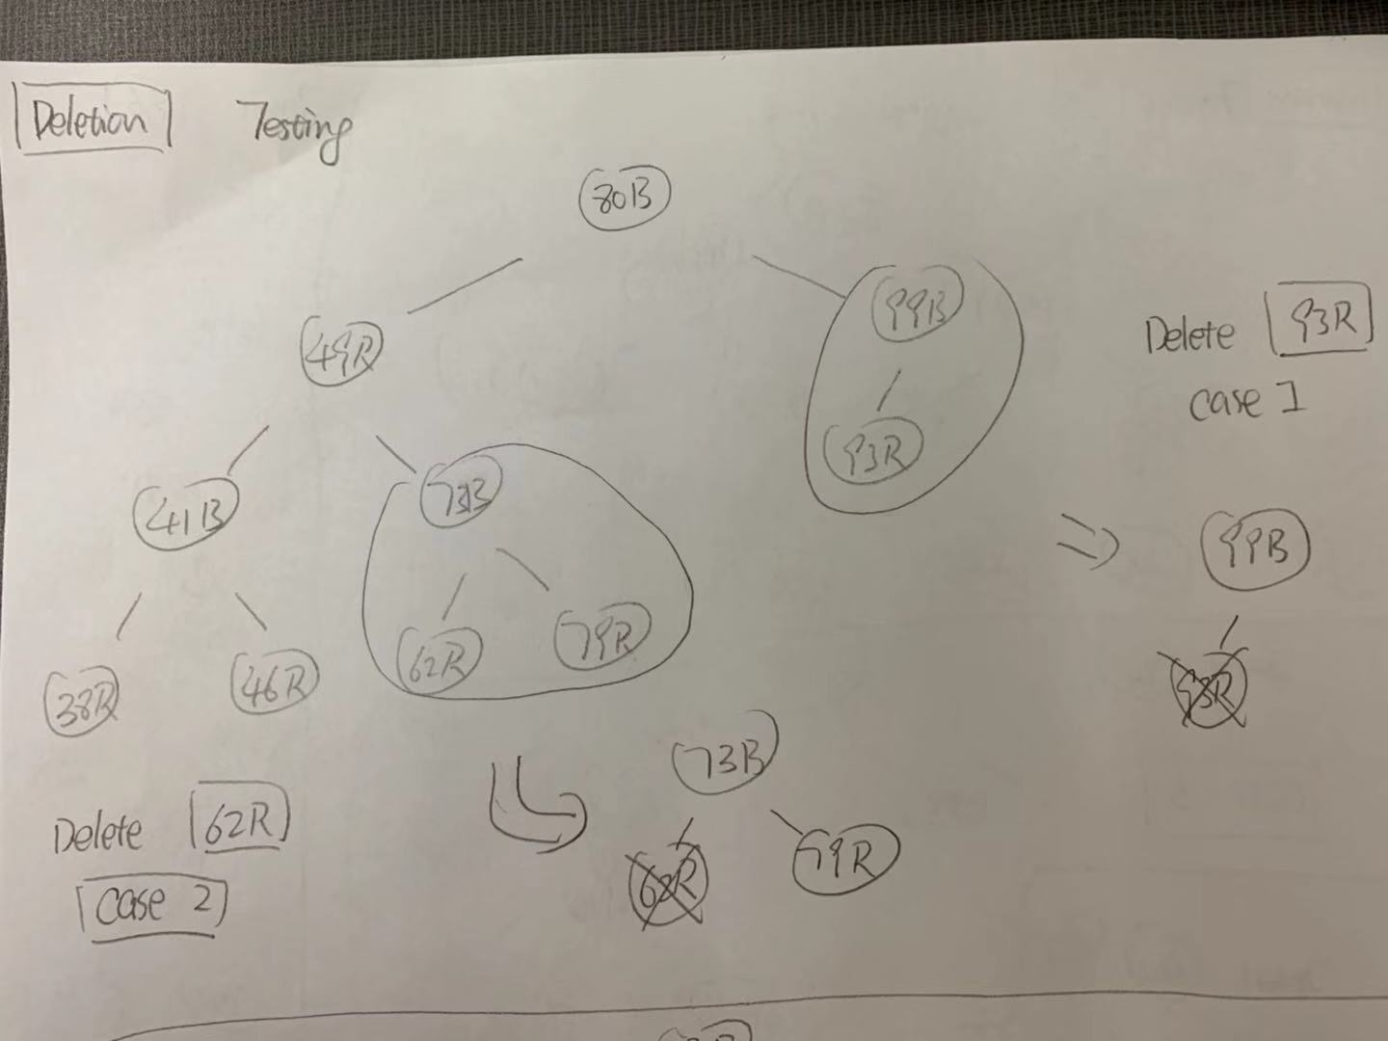

From the tree above, we found the 93R is the Node that satisfied that **Case 1,** after the deletion, since it didn’t affect any of the properties, it just deleted without any changes. Also, we found the 62R is the Node that satisfied that **Case 2,** after deletion, since it didn’t affect any of the properties too., it also deleted without any changes.

Since we can’t find Case 3 and Case 4 in this tree, I would add insert 73, 52, 55, 43, 92 and 99, And we found the both Case 3 and Case 4.

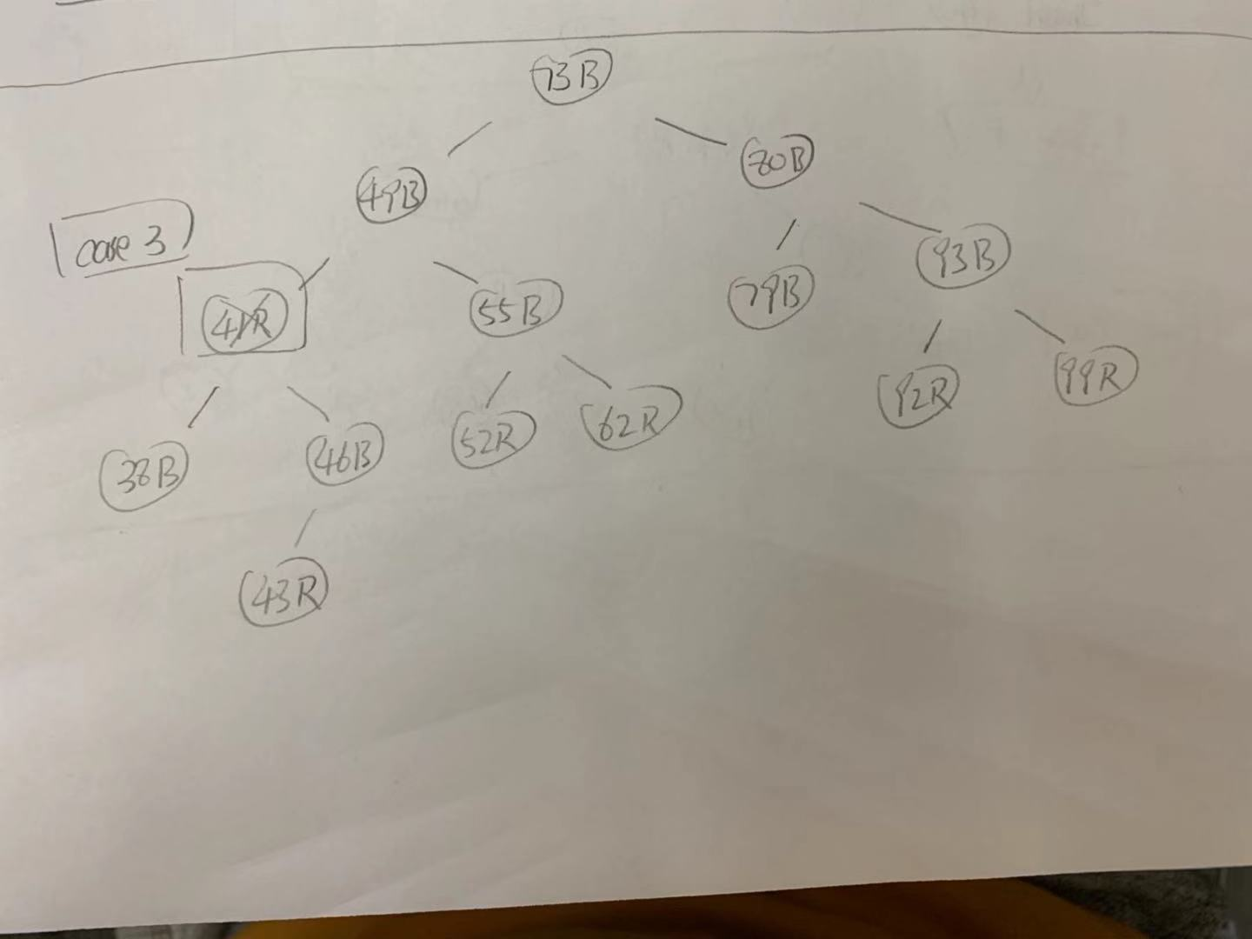

From the tree above, we find the 41R Node is satisfied the **Case 3** of the deletion FixUp, its color is red, and it have both children. After deletion, the tree looks like this:

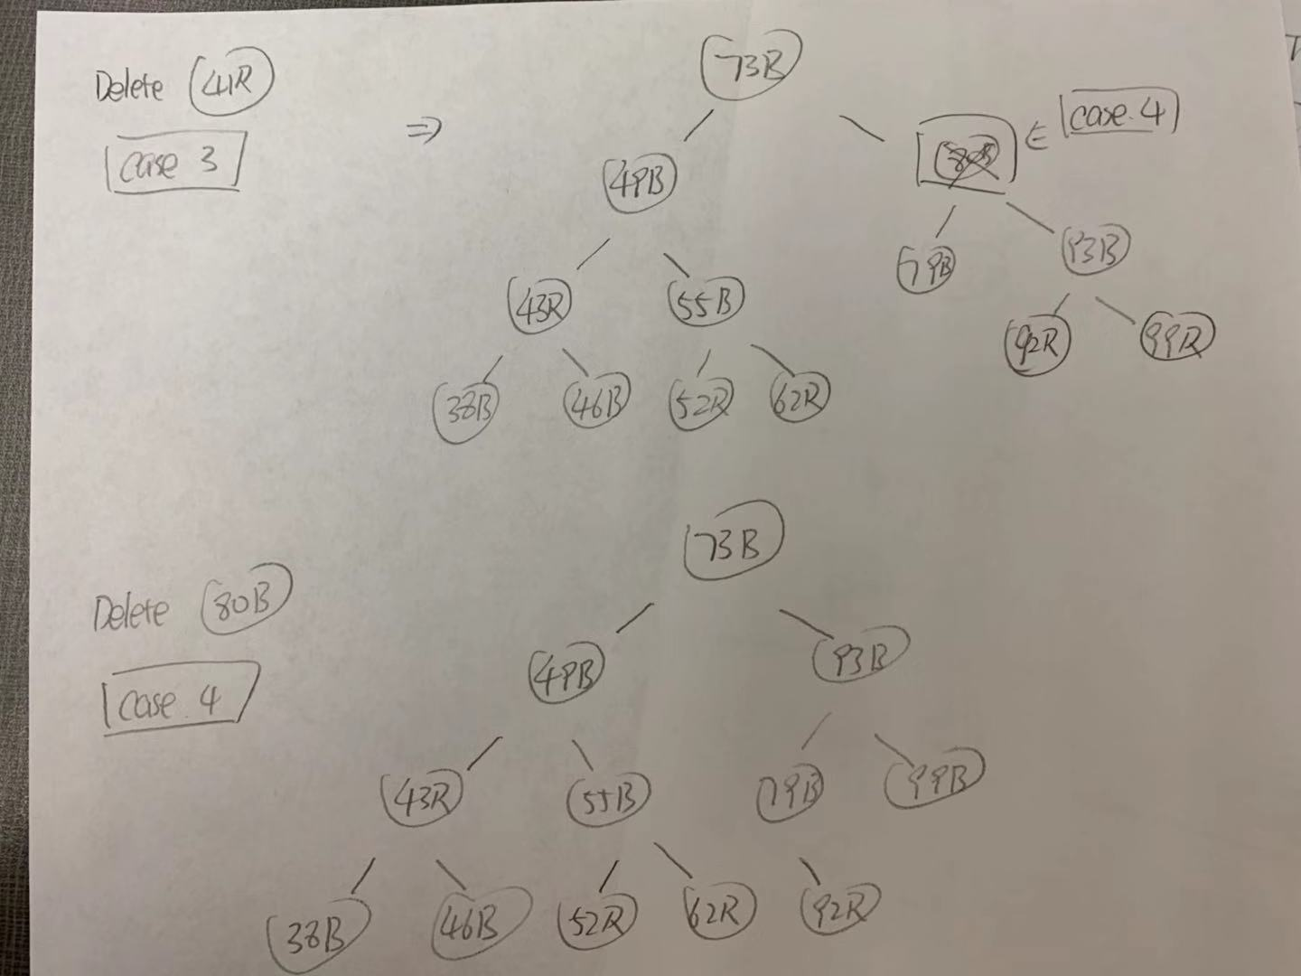

It replaced the successors and keep the color properties and tree balance the same.

At the same time, we found the 80B is the Node that satisfied the **Case 4**, it has bother children and including itself and its parents are all black, after deletion, the tree looks like this:



It does the left rotate and keep the color properties and tree balance that satisfied the RB Tree.

Thus, all 4 cases of deletion tested out, and it all worked.

**6) Problems**

* One of the biggest problems is that RB tree using Nil replacing Root and it causes the method like Tree minimum and in order walk have bugs and hard to find them.
* Deletion is harder to implement in RB Tree than in BST due to the color properties and one mistake can ruin the whole tree.
* Tried to build the Drawing in the GUI by using different framework such as Spring and Swing, but unable to implement successfully due to the lack of time and knowledges.

**7) Learnings**

* Be able to implement RB Tree and understand each methods of RB Tree, especially insertion and deletion. Understanding more the advantages of using RB Tree.
* Better understanding the JavaFx and the functions come with it.
* Be able to write cleaner code and cleaner reports comparing to the previous ones.